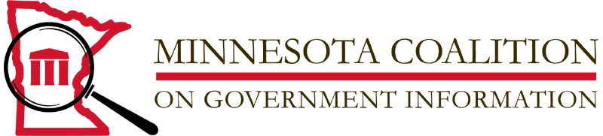

**For release March 1, 2011**

**Don Shelby and State Senator Don Betzold receive John R. Finnegan Freedom of Information Award**

Former WCCO-TV Anchor and MinnPost columnist Don Shelby along with former State Senator Don Betzold are this year’s John R. Finnegan Freedom of Information Award winners. Today’s announcement from the Minnesota Coalition on Government Information (MNCOGI) is unusual in that the MNCOGI Board of Directors broke with its usual practice of selecting only one recipient. The board decided it was important to honor the significant but greatly varied roles these two individuals have played in freedom of information activities in Minnesota.

Sen. Betzold of Fridley, Minnesota, spent years in the legislature developing meaningful policy about freedom of information while Shelby spent many years using those policies and other freedom of information tools to advance the public's right to know about its government.

For a number of years, Senator Betzold was the consistent champion of the public's right to know in the Minnesota Senate.  Many times he took on the often thankless task of carrying the annual data practices bill.  Even though advancing the cause of freedom of information does not enjoy a reputation for being a high visibility political activity, Senator Betzold continually used his strong leadership skills to move bills through the legislative process. His work included significant reform efforts to deal with the increased computerization of government information.  Senator Betzold also promoted the cause of transparency by authoring bills to assure access to government information on line.  He took firm, principled stands on maintaining open records and open meetings even when it was politically unpopular to do so.  
  
Don Shelby first gained wide spread recognition among Minnesotans for his work with the WCCO I-Team.  Often the I-Team focused its investigative efforts on governmental activities. Shelby became proficient at using the state Data Practices Act and the federal Freedom of Information Act to gain access to government information. Shelby made over 1500 data requests. The resulting stories kept the public informed about what the government officials were doing and frequently cast a bright light on shady practices.   
  
Shelby shared his expertise at uncovering government data with other reporters through publications and educational activities. He was an active member and director of the national group, Investigative Reporters & Editors.

Throughout his investigative career he won numerous awards including an Emmy for his expose of poor ambulance response times. In that story he used government data to prove that certain communities were not getting the level of life-saving service they expected. Shelby’s nomination noted his tenacity in dealing with government officials. Shelby let them know he was, “prepared to stick around as long as it took to get the public all information that was legally available."

The John R. Finnegan Freedom of Information Award was established by MNCOGI in 1989 and is named for the retired senior vice-president and assistant published of the *St. Paul Pioneer Press.* Finnegan is a life-long stalwart of open meetings, open records and the First Amendment.  
  
This year's Finnegan Awards will be presented at a ceremony at noon at the Minneapolis Central Library 300 Nicollet Mall on Wednesday, March 16, 2011.  March 16, is the birthday of President James Madison and is celebrated annually across the country as Freedom of Information Day. The awards presentation is free and of course, open to the public.

Additional information on the MnCOGI website at [www.mncogi.org](http://www.mncogi.org/)

Or contact MNCOGI Chair Helen Burke at MNCOGI [at] gmail.org.

_________________________________________________________________________

MNCOGI is a 501(c) 3 nonprofit organization committed to the promotion of public access to government information and transparency of government operations. MNCOGI Board members are John Borger; Helen Burke, Chair; Sue Campbell; Kirsten Clark; Duchesne Drew; Don Gemberling, Secretary; Art Hughes; Gary Hill; Jane Kirtley, Robbie LaFleur, Treasurer; Don Wyatt.