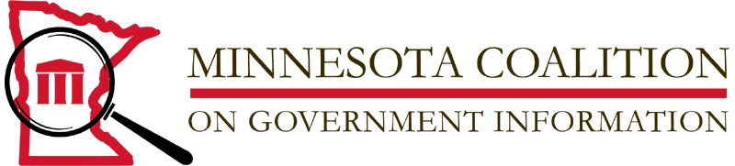

For release March 5, 2012

Amy Goodman will be the keynote speaker at the 2012 Freedom of Information Day and Finnegan FOI Award Ceremony

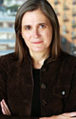
Award-winning journalist Amy Goodman will be the keynote speaker at the annual Freedom of Information Day and John R. Finnegan Freedom of Information awards ceremony. The event is set for 4 pm on Friday March 23, 2012 at the Hennepin County Library-Minneapolis Central, Pohlad Auditorium, 300 Nicollet Mall, Minneapolis, Minnesota.

Goodman is the host and executive producer of Democracy Now!, a daily, global, independent news hour airing on more than 1,000 public television and radio stations worldwide. Goodman is the first journalist to receive the Right Livelihood Award, widely known as the 'Alternative Nobel Prize' for "developing an innovative model of truly independent grassroots political journalism that brings to millions of people the alternative voices that are often excluded by the mainstream media."
Goodman was one of dozens or journalists arrested by Twin Cities police while covering demonstrations at the Republican National Convention in St. Paul in 2008. Her subsequent federal lawsuit against local police and the Secret Service won a $100,000 settlement and a pledge by St. Paul police to implement a training program about the First Amendment rights of the press and public and the proper procedures for dealing with the press while covering demonstrations.

Goodman is the author of four New York Times bestsellers. Her latest book, Breaking the Sound Barrier, is about the power of independent journalism in the struggle for a better world. A book signing will follow the awards ceremony and speech.

The John R. Finnegan Freedom of Information Award was established by MNCOGI in 1989 and is named for the retired senior vice-president and assistant publisher of the St. Paul Pioneer Press. Finnegan is a life-long stalwart of open meetings, open records and the First Amendment.

Freedom of Information Day is usually commemorated each year on March 16, the birth date of James Madison, champion of access and transparency in government. This year’s ceremony was moved to March 23rd so that Ms. Goodman could join us.

Additional information is available on the MNCOGI website at www.mncogi.org
Or contact MNCOGI Chair Helen Burke at MNCOGI [at] gmail.org.

MNCOGI is a 501(c) 3 nonprofit organization committed to the public’s right to know, the promotion of public access to government information and transparency of government operations. MNCOGI Board members are John Borger; Helen Burke, Chair; Kirsten Clark; Hal Davis, Duchesne Drew; Don Gemberling, Secretary; Art Hughes; Gary Hill; Jane Kirtley, Robbie LaFleur, Treasurer.

